SVN Standards and Structure Document

Version 1.0

**SVN Link :** <https://63.128.188.19/svn/008061/icoe/mule/>

**STEP 1:** Under SVN root create the folder with project name and under the project folder create 3 more subfolders “Branch”, “Tag” and “Trunk” as below.

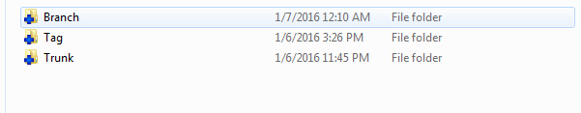

**STEP 2:** Under Branch, Tag and Trunk folders, Create the sub folders “Build”, “Docs”,”Libraries”,”Source” as below.

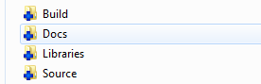

**STEP 3:** The production main release versions of the code and related artifacts should go into Trunk” folder.

The Current under development and the related artifacts should go into “Branch” folder.

The code version and artifacts related to Break fix or enhancement that was performed on top of the production main version should go into “Tag” folder.

And below are the details on what should be checked-in into individual folders under “Branch” or “Tag” or “Trunk”

1. Check-In the integration deployable zip under “Build” folder.
2. The actual Source code under “Source” folder.

**What to check in, what to ignore**

Not all files in a Mule project need to be checked into source control system. Some files are metadata generated by Studio and other tools in order to keep track of the project, others are temporary information generated by the build process and are completely machine-dependent. Checking in these files will cause conflicts in other team members' projects, or will cause their builds to fail.

**Check in these files and folders:**

* src/ folder (source code).
* mappings/ folder (Data Mapper maps).
* The mule-project.xml file (Studio project descriptor).
* pom.xml (for Maven-based projects, the project's build configuration).

**Do NOT check in these files and folders. They are either temporary or:**

* .classpath (Studio metadata)
* .settings (Studio metadata)
* target/ folder (contains compiled code)
* bin/ folder (contains compiled code)
* flows/ folder (*for Studio 3.5.0 and older only*, contains flow metadata files)

1. All the dependent Jars and Libraries under “Libraries” folder.
2. All the documents should be placed under “Docs” folder.